Introduction to DALI

DALI stands for **D**igital **A**ddressable**L**ighting**I**nterface.

DALI is a standard for a bus system for controlling light sources.

Since end of 2014, the DALI 2 standard has been introduced. In contrast to DALI it additionally contains specifications for input devices such as:

* sensors for occupancy or brightness and buttons
* switches
* slider or similar

These specifications ensure the interoperability between devices from different manufacturers. Only certified devices are allowed to use the DALI-2 logo.

DALI was intended to be a better version of the 1-10V lamp interface, so the objectives were to introduce a system that is easy to install, offers high flexibility while being cost effective at the same time.

Disadvantages of the 1-10 Volt system:

* A control cable length dependent voltage drop causes a lower voltage at the device input. Different ballast have different cable lengths, resulting in a visibly different brightness of the lamps.
* As it is a static system, changes in the floor plan may require a re-wiring.

Advantages of the DALI system:

* The communication bus transmits digital signals, therefore a signal voltage drop doesn't influence the brightness.
* Grouping of lamps is defined in the configuration software, so no wiring must be changed when splitting or merging rooms.
* Numerous features: dim time/ramp time, minimum/maximum brightness for dimming, storage and recall of lighting scenes, failure notifications, …
* Immediate feedback (the dimm level) on the DALI channel

DALI device classes/types consist of:

* **Ballasts** – different ballasts can handle different lamp types and different control options (on/off, dimming, emergency light, color temperature, …). All certified units can be controlled by L-DALI controllers.
* **Buttons and sensors** – standardized in DALI-2 only. For a sensor that is not DALI-2 certified, please refer to the LOYTEC compatibility list in order to confirm, if it has been tested for the interoperability with LOYTEC devices. Button module BM2 and mulit sensor MS2 belong to that type of devices.
* **Controllers** – required for setting up and operating a DALI network. Examples for this device type are the L-DALI devices.

A DALI network consists of **exactly** one application controller (only one master is allowed), input devices, bus power supplies (which may be built into any of the products), control gear (e.g. electrical ballasts, LED drivers and dimmers) that have DALI interfaces. Application controllers can control, configure or query each device by means of a bi-directional data exchange. The DALI protocol permits devices to be individually addressed and it also allows multiple devices to be addressed simultaneously via group and broadcast messages.

Each device is assigned a unique short address in the numeric range 0 to 63, making possible up to 64 control gear plus 64 control devices in a basic system. Address assignment is performed over the bus using a "commissioning" protocol, usually after all hardware is installed. Data is transferred between devices by means of an asynchronous, half-duplex, serial protocol over a two-wire bus, with a fixed data transfer rate of 1200 bit/s. The bus is used for both signal and power. A power supply provides up to 250 mA at typically 16 V DC.

Colour Control:

IEC 62386-209 describes color control gear. This describes several color types - methods of controlling color. The most popular of these is tunable white, and was added to DALI-2 certification in January 2020.

Emergency Lightning:

IEC 62386-202 describes self-contained emergency lighting. Features include automated triggering of function tests and duration tests, and recording of results. These devices are currently included in DALI version-1 registration, with tests for DALI-2 certification in development. Such DALI version-1 products can be mixed with DALI-2 products in the same system, with no problems expected.Bovenkant formulier

Guidelines for DALI Cabling

Current consumption of the DALI circuit:

Every device in the DALI circuit draws electricity via the DALI circuit. The sum of the current consumed in the DALI circuit is allowed do not exceed the maximum current of the DALI power supply (<250mA).

To determine the current consumption of a DALI circuit, both the current consumption of the DALI operating devices and the DALI control units are taken into account. The current consumption of a DALI control gear with 2 mA is in the DALI standard fixed.

Maximum cable length:

The maximum cable length results from the maximum permitted voltage drop on the DALI cable, it is with a maximum of 2 V defined. This is typically ensured when wiring with a 300 m cable length and a cable cross-section of 1.5 mm². An additional voltage drop at individual terminal points must be observed. When using a smaller cross-section than 1.5 mm² the maximum cable length is reduced accordingly.

Calculation of the voltage drop:

The following equation applies to the calculation of the voltage drop:

| **Uv** | **voltage drop in V** |
| --- | --- |
| **I** | **current in A (0.25 A)** |
| **S** | **cross section in mm2** |
| **l** | **cable length in m** |
| **y** | **Electrical conductivity in m / (Ohm mm2), for copper lines: 56 m / (Ohm mm2)** |

Example: DALI circuit with a cable length of 300 m and a wire cross-section of 1.5 mm²  
This means:

* With a cable length of 300 m, the voltage drop of the cable is 1.786 V.
* 0.214 V voltage drop remains for terminal points (contact resistors)

Rule of thumb:

Since it is somewhat unwieldy to calculate the permitted cable length using the voltage drop, the following rule of thumb applies: When using a cable cross-section of 1.5 mm², the maximum cable length is 300 m. If a smaller cable cross-section is used, the possible cable length is reduced accordingly.

| **Cable length** | **minimum cross section** |
| --- | --- |
| <100 | 0.5 mm² |
| 100-150 | 0.75 mm² |
| > 150 | 1.5 mm² |

Wiring:

* The polarity of the DALI cable does not have to be taken into account.
* The DALI signal is not SELV. The installation regulations for low voltage apply.
* No special network topology regulations (star and mixed networking permitted). No ring and wire mesh networking.

Example Installation:

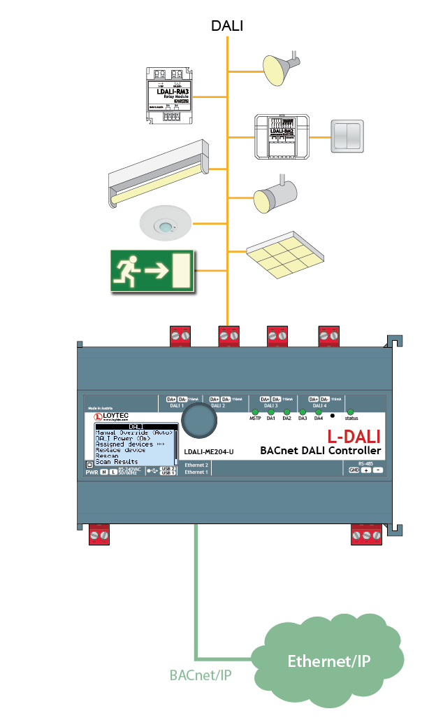

Bovenkant formulier

Onderkant formulier

Bovenkant formulier

**Limits and Features of the DALI Protocol**

Limits of the DALI Protocol

A DALI channel allows the connection of up to 64 ballasts and assigning ballasts to up to 16 groups. Buttons or sensors that don‘t consume an individual address can be used in addition on the same channel.

To each device up to 16 light scenes can be assigned.

The bit rate is 1200 bit per second, which is rather slow. That‘s why the preferred way to switch a group of lamps is to use the group addresses (multicast) instead of the individual addresses, as the user would notice delays between the switched lamps.

The high level of the signal is the supply voltage, and must be between 9.5 and 22.5V, typically 16V. The low level is 0 +/- 6.5V, and is generated by a short circuit between the two DALI signal lines.

The supply current must not exceed 250mA per channel, as it might damage the part of the devices‘ circuits that short the signal lines. Furthermore, the DALI bus supplies buttons or sensors, while ballasts receive their supply voltage mainly from the mains supply (120/230 V~). DALI is a two-wire bus system with a maximum wire length of 300 meters. This means, that the cable length between any combination of two devices (controllers, sensors, ballasts) must not exceed 300 meters. Please note the required cross-sectional area of the cables dependent on the cable length.

The device connection topology on the DALI channel is very flexible, anything but a ring structure can be implemented.

Features of the DALI Protocol

In a DALI system, the connected devices (ballasts) store information such as:

Short address (the individual address of each device, value is 0-63)

Group(s) ID (a device can be in one ore more groups)

Light scenes

Ramp Rate or Fade Time (see below)

The dim values for normal and for emergency lights after a supply voltage cutoff or during a system failure

Difference between Ramp Rate and Fade Time:

Ramp Rate: defines a delta of the dim value per second: unit: [%/s]

Fade Time: defines the time for dimming from a specified dim value to another one: unit: [s]

Example:

Two lamps are having different dimm levels. Lamp A has dimm level 40%, lamp B 60%. The lamps are set to "Ramp Rate" (5%/s). Now both lamps should dimm up to 80%. As the "Ramp Rate" is 5%/s, lamp B will reach this dimm level after 4 seconds, lamp A after 8 seconds. Setting the he lamps to "Fade Time" both lamps will reach the dimm level at the same time.

Physical differences between DALI ballasts and DALI sensors:

DALI ballasts have 5 connections:

P+N+E for the power supply

DA+ and DA- for the DALI bus

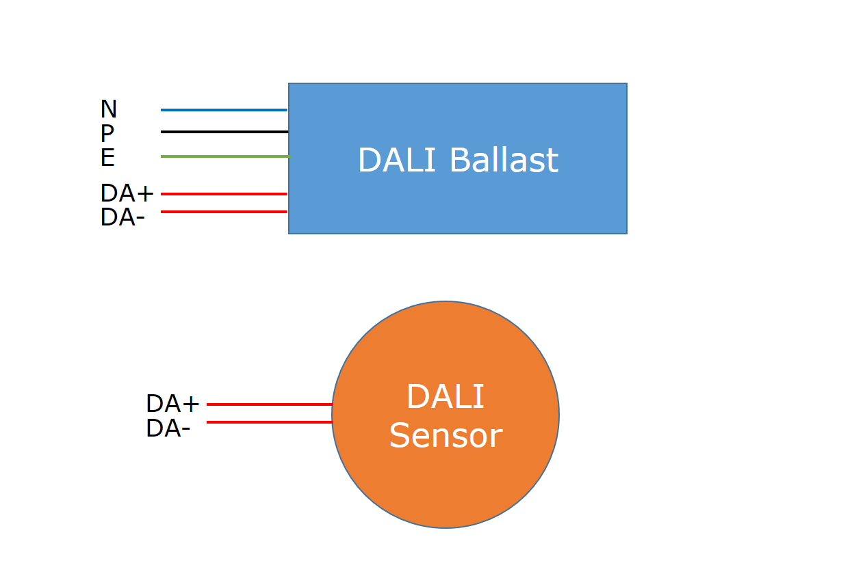

DALI sensors use the DALI bus not only for communication, but also for power supply. Hence, their current consumption is typically 3-6 mA, whereas ballasts consume a maximum of 2 mA.

The maximum current consumption in a DALI channel is, as mentioned before, 250 mA. This value must not be exceeded, as this could damage the interface circuits of the connected devices.

For DALI ballasts and sensors the polarity on the DALI bus is irrelevant. However, when using more than one power supplies, attention must be paid for the correct connection regarding the polarity.

DALI Addressing:

Via the short address each device on a DALI bus can be addressed individually. Please note, that due to the rather low speed of the communication protocol the usage of the group address (multicast) is the preferred addressing strategy.

During the installation of a DALI system e.g. on a construction site, the connected devices can already be switched on and off without being configured. Broadcast commands allow to switch on and off devices, even if they have not yet been assigned a short address.

Since DALI-2 has been introduced, buttons and sensors are standardized, which ensures interoperability. For DALI devices that do not meet the DALI-2 standard, the compatibility list on the LOYTEC web page gives information if a specific sensor will work in a DALI network with an L-DALI controller. The compatibility list can be found on the LOYTEC web page under [Support -> Download -> White Papers](https://www.loytec.com/support/download/doc_download/2054-an011e-l-dali-compatibility-list). Please log in first, only authenticated users have the permission to download the file. Note, that the list assumes that the latest firmware version for the L-DALI controller has been installed. With an older firmware version, less sensors will be supported.

Information about LOYTEC DALI Devices

The LOYTEC L-DALI controllers can be divided by the following criteria:

Number of DALI channels:

* 1 channel
* 2 channels
* 4 channels

Used protocol on BMS side:

* BACnet (based on IP or MSTP)
* LON = CEA709 (based on FT-10 or IP-852)

Power supply for the DALI channel(s):

* integrated (controllers with 1 channel, 2 and 4 channels since production W06/2019. Per default disabled. Needs firmware version 6.4.6 or higher) - maximum of 230mA if one channel, 116mA per channel else.
* external  
  Afbeelding met tafel

  Automatisch gegenereerde beschrijving

What happens, if the power supply doesn’t deliver enough power for the connected devices?

* Power supply switches off due to overheating (protection circuit)
* Devices go offline
* DALI LED on L-DALI lights red (temporarily)

The Web UI gives an indication regarding the current consumption of each device on the DALI bus.

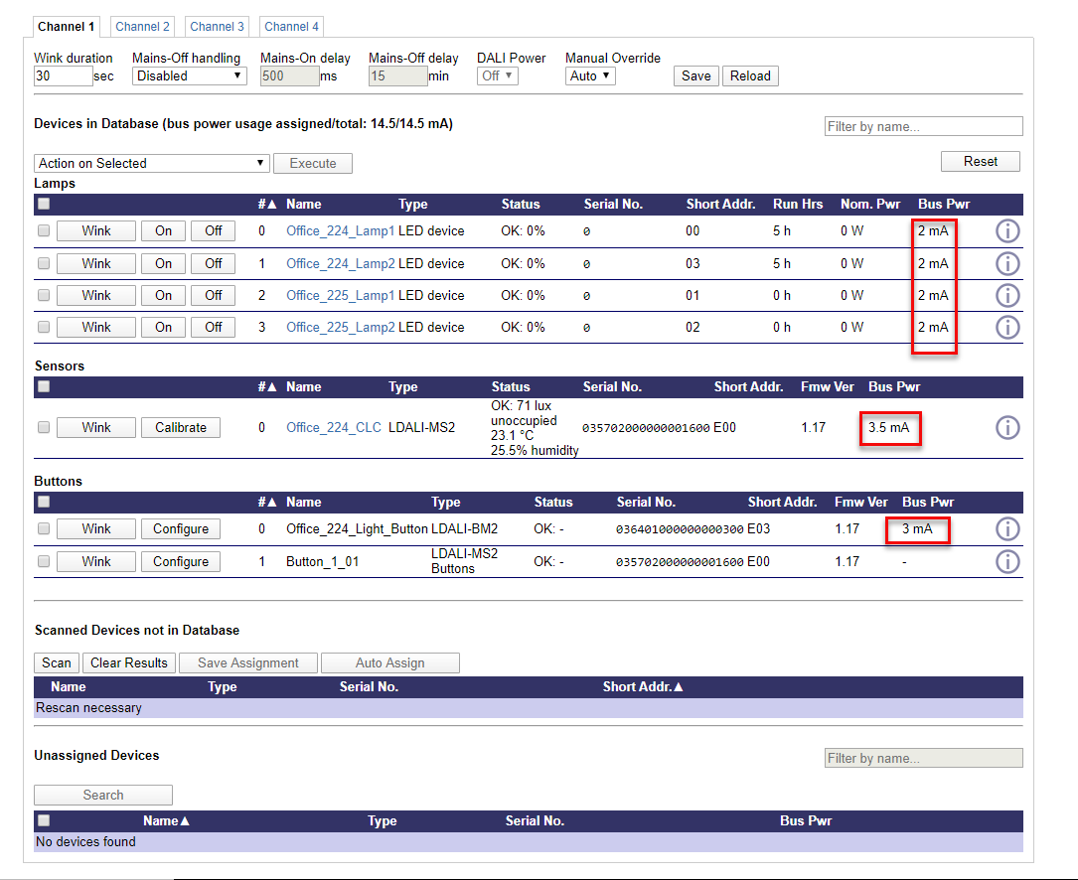

Note: The power consumption of some devices is known by the system. If no information is available, the system uses the maximum allowed power for a certain device type defined in the DALI standard for calculating the power consumption.  
  
To add additional power, the LDALI-PWR2-U or the LDALI-PWR4-U can be used

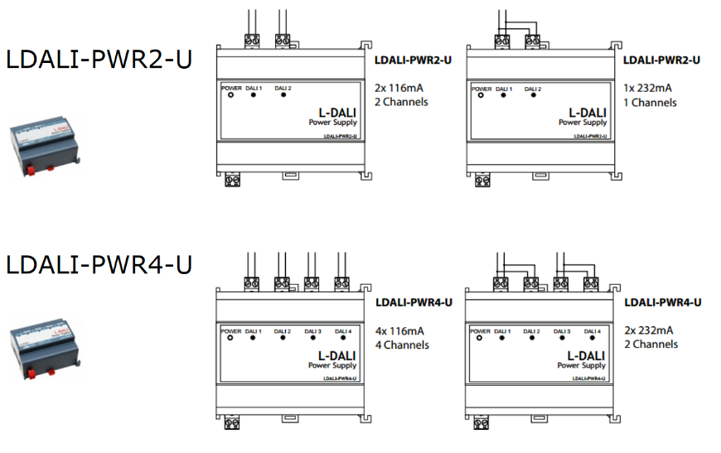

Note: Is is**NOT** allowed to power the channel with more than 250mA. This might damage the equipment.

**LDALI-MS2**

The DALI multisensor LDALI-MS2 includes

* Occupancy sensor
* Luminance sensor which can measure a light intensity up to 4000 lx with a resolution of 1/8 lx
* Temperature & humidity sensor, enabling e.g. dew point measurement
* 3 digital inputs on the back enable the connection of input devices such as switches or buttons, window contacts or a dew point sensor. This can save wire costs and wire insertion efforts.
* IR receiver for the optionally available IR remote control L-RC1. This enables control of lighting or sunblinds, and can also be used in HVAC applications.

The MS2 is supplied via the DALI bus, so no external power supply is required.

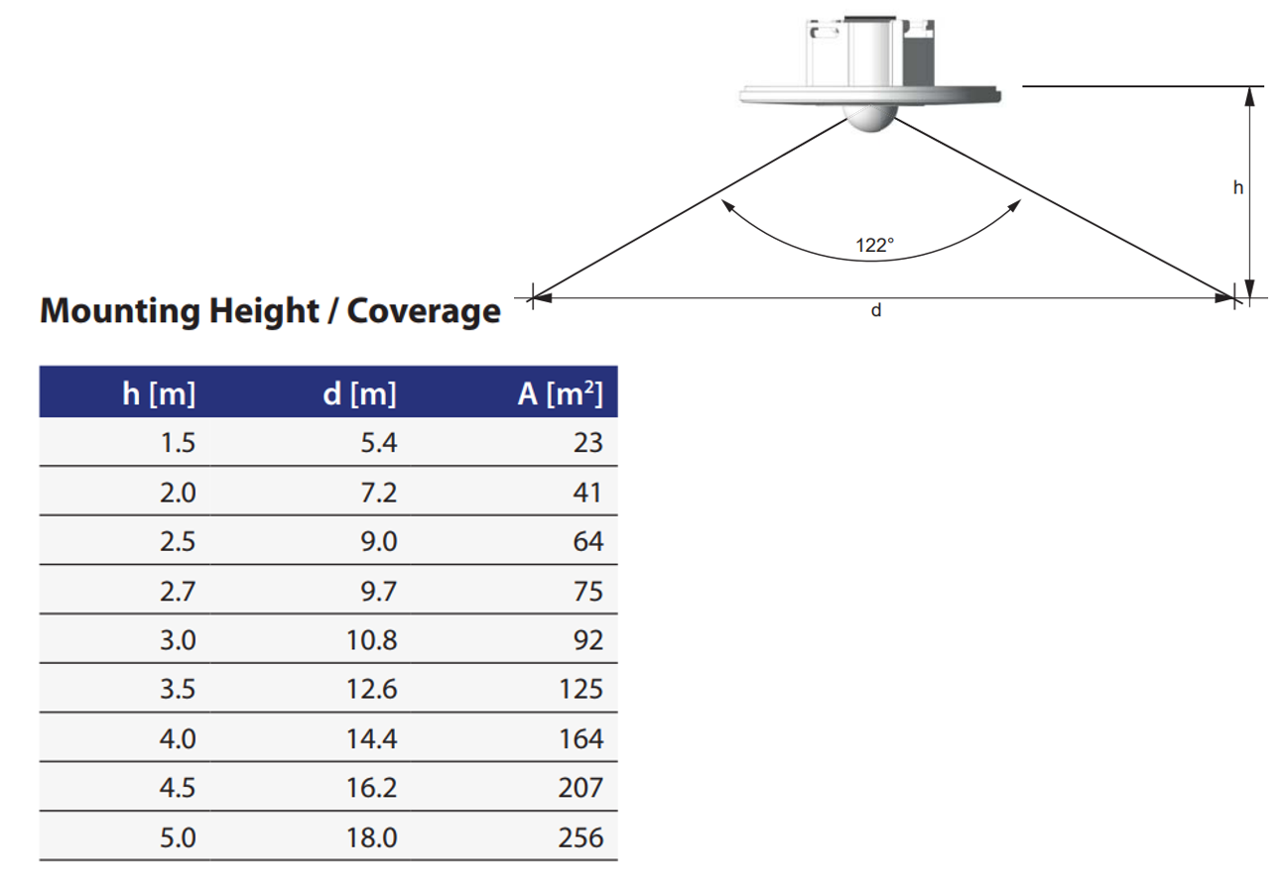

Avoid wrong mounting:

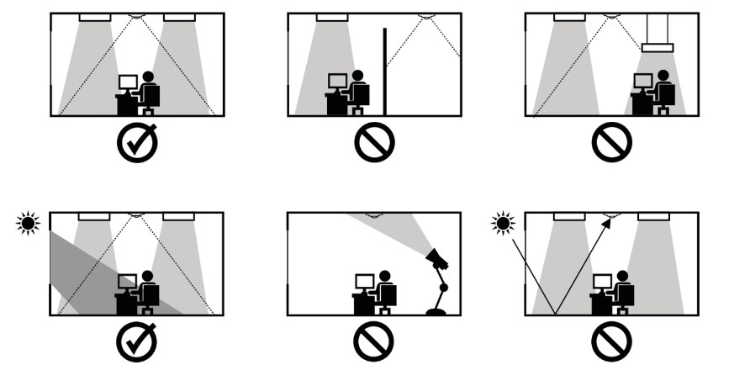  
This video shows the right technique to install the springs:

**https://youtu.be/Cluy_xHxZL0**

**LDALI-BM2**

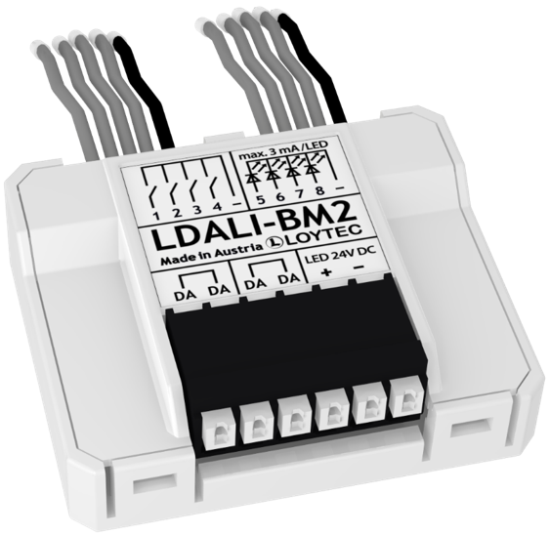

The LDALI-BM2 button module integrates conventional buttons and switches in a DALI channel.

The module is directly connected to a DALI bus, which also supplies it. The BM2 includes:

* 2 digital inputs enable the connection of switches or buttons
* 2 universal inputs enable the connection of potentiometers, faders, silders or digital sensors
* 4 outputs for activation of status LEDs (requires external 24V for LED supply)

**LDALI-RM3, LDALI-RM4**

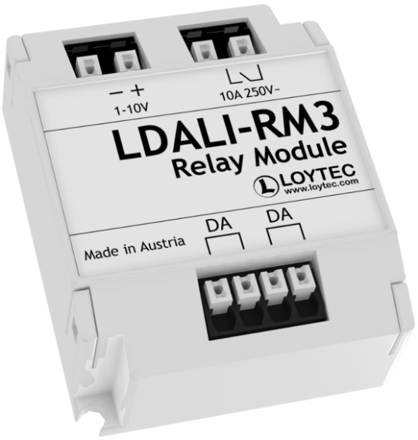

The LDALI-RM3 is able to switch loads up to 2500 VA (AC) or 300 W (DC) on a DALI bus.

* Up to 2500VA AC (10A @ 250V~)
* Up to 300W DC
* 1-10V for dimmable ballasts

Features

* Easy integration into LOYTEC L‑DALI lighting systems and LROC‑40x room automation controllers
* Device configuration with the free L‑DALI Configurator or via the built‑in web server of the L-DALI controller
* Programmable switching output for standard consumers in the power grid
* Universal voltage support (120 – 347 V AC)
* Up to 64 LDALI‑RM Relay Modules per DALI channel with sufficient dimensioned bus supply
* Supplied via the DALI channel
* Potential‑free, bi-stable relay make contact
* Analog Interface 0 – 10 V and 1 – 10 V for legacy dimmable lamps
* DALI specification IEC 62386‑208 (Device Type 7 – Switching Function) supported
* DALI specification IEC 62386‑206 (Device Type 5 – Converter) supported
* Configurable relay position in case of power loss
* Zero cross switching function

Besides the gateway function, the L-DALI controllers provide features for light control, such as

* occupation based control (saving energy)
* bright out feature: automatically switches on/off the light, luminance-dependent on the natural light
* constant light control: if the ambient light falls below a defined luminance setpoint, a closed loop control algorithm calculates the required dim value
* scheduled lighting
* replacement of DALI devices can be done easily, as the L-DALI controller allows to backup the DALI configuration, after replacement, the configuration can be downloaded to the new device
* the backup function can also be used for the L-DALI controller itself, allowing to replace an L-DALI controller in case it fails
* SMI and EnOcean devices can be connected to the L-DALI controller as well, enabling the integration of sunblinds or wireless sensors into light control applications

Preparing an L-DALI Installation offline

In this course the following setup is used:

* LDALI-ME204-U (only channel one is used)
* LDALI-MS2
* LDALI-BM2 with a rocker switch
* four ballasts with 4 LED stripes

Scenario:

Four Lamps are located in room "Office_224" (two on the east side and two on the west side). Windows are located at the west side of the building.

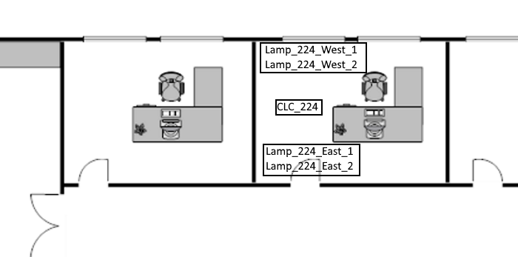

Goal of this project:

* A constant light solution if the office is occupied
* The lamp located near windows should "turn on later", as normally there is more light in this area
* During night (7 pm-7 am) the light lux setpoint is reduced compared to the day setpoint (to reduce glare for the night security officer)
* A button should be installed to perform the following tasks:
  + If a button is pressed the light should go to 100% or 0%
  + If another button is pressed they system should go back to automatic mode
  + Two buttons for dimming up and down

Solution:  
The following devices will be used to fulfill the requirements of the customer:

* LDALI-ME204-U
* LDALI-MS2
* LDALI-BM2 with a rocker switch

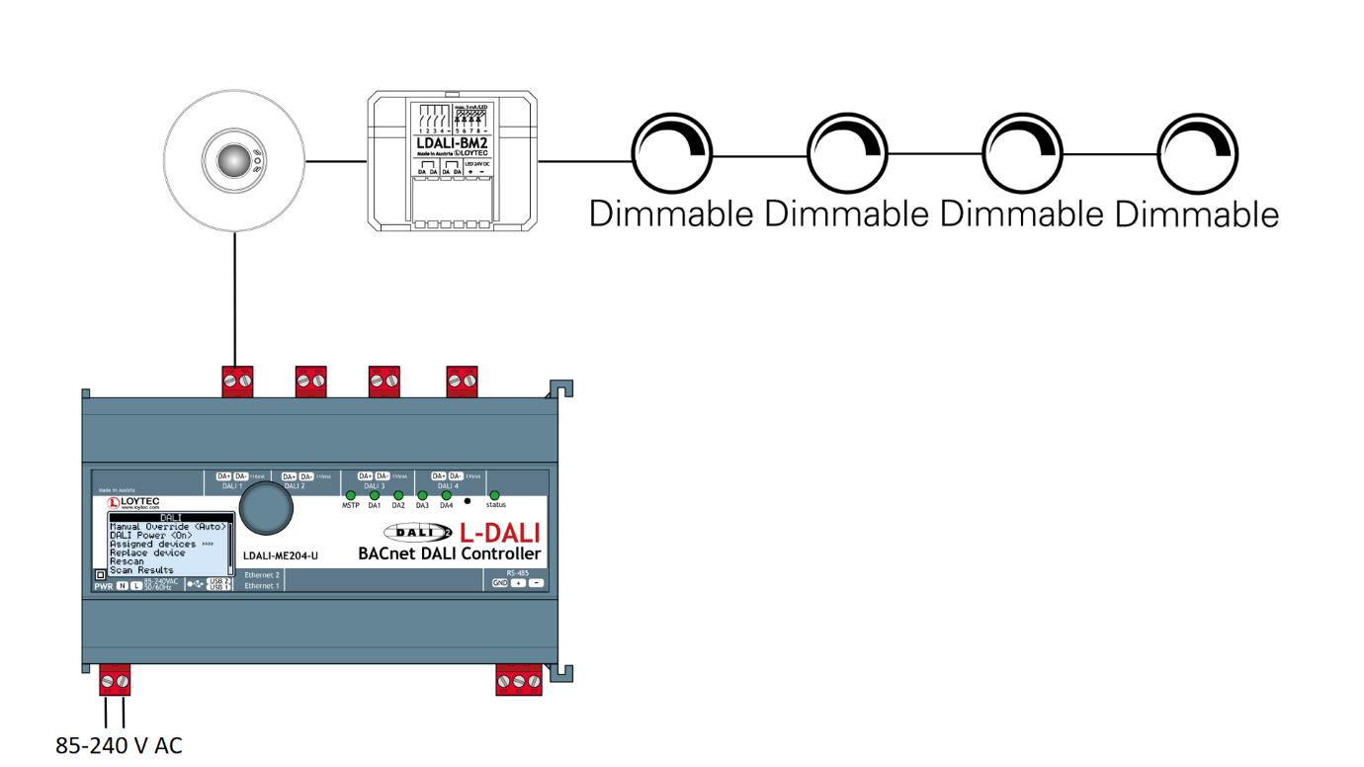  
  
The mode of the constant light controller will be set to "Regulator". This means, that a light sensor and an occupancy sensor is installed (LDALI-MS2). The room will be dimmed (according to the configured setpoint) automatically when the room is occupied. When there is no occupancy detection for longer time (in this example five minutes) the room should go to "unoccupied" and the lights should dimm down and turn off.  
  
In the following video an offline configuration for the lamps and multisensor is explained. Configuring the button module will be explained in one of the next lessons.

<https://www.youtube.com/watch?v=eG_ZSnEYIRM&feature=emb_rel_end>

Scanning DALI Devices with a prepared Configuration

In the last lesson we have prepared an offline configuration. It is now time to connect to the LDALI-ME204-U and to download it to this device. Before doing so make sure, that your project settings are configured correctly. The project name should be set, as well as the "Device Configuration Download". Normally it is not necessary to download everything. To save time configure that you will be ask what to download.

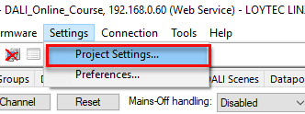

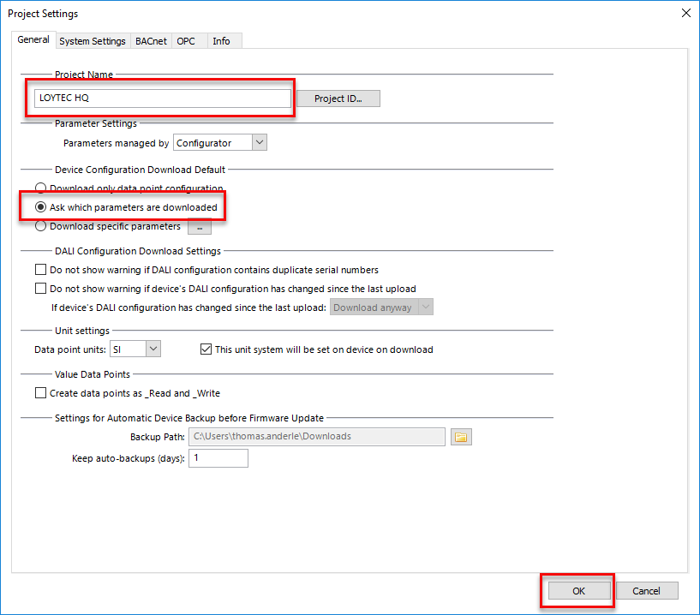

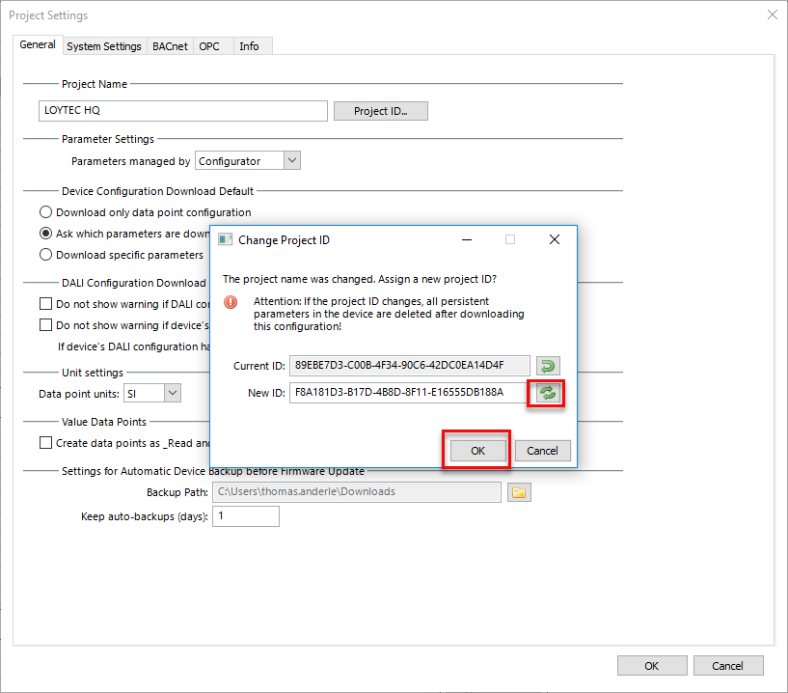

Connect to the device

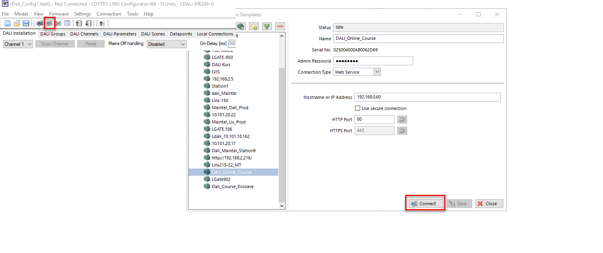

and download the configuration

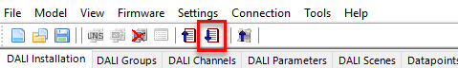

As we did not change (or configure) schedulers, L-WEB projects or global connections it is not necessary to download them.

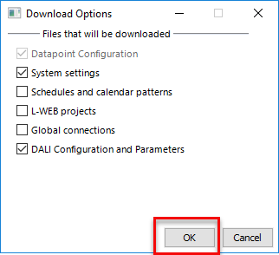

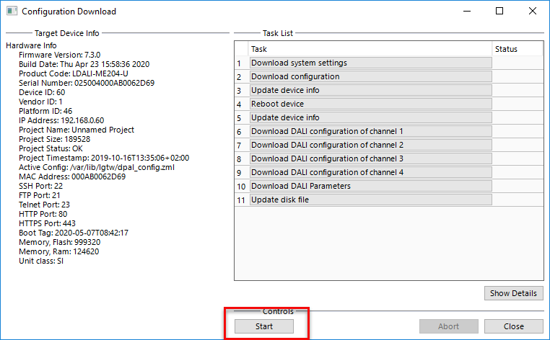

In order to commission a DALI network, a bus scan must be performed using the built in Web UI of the L-DALI device.

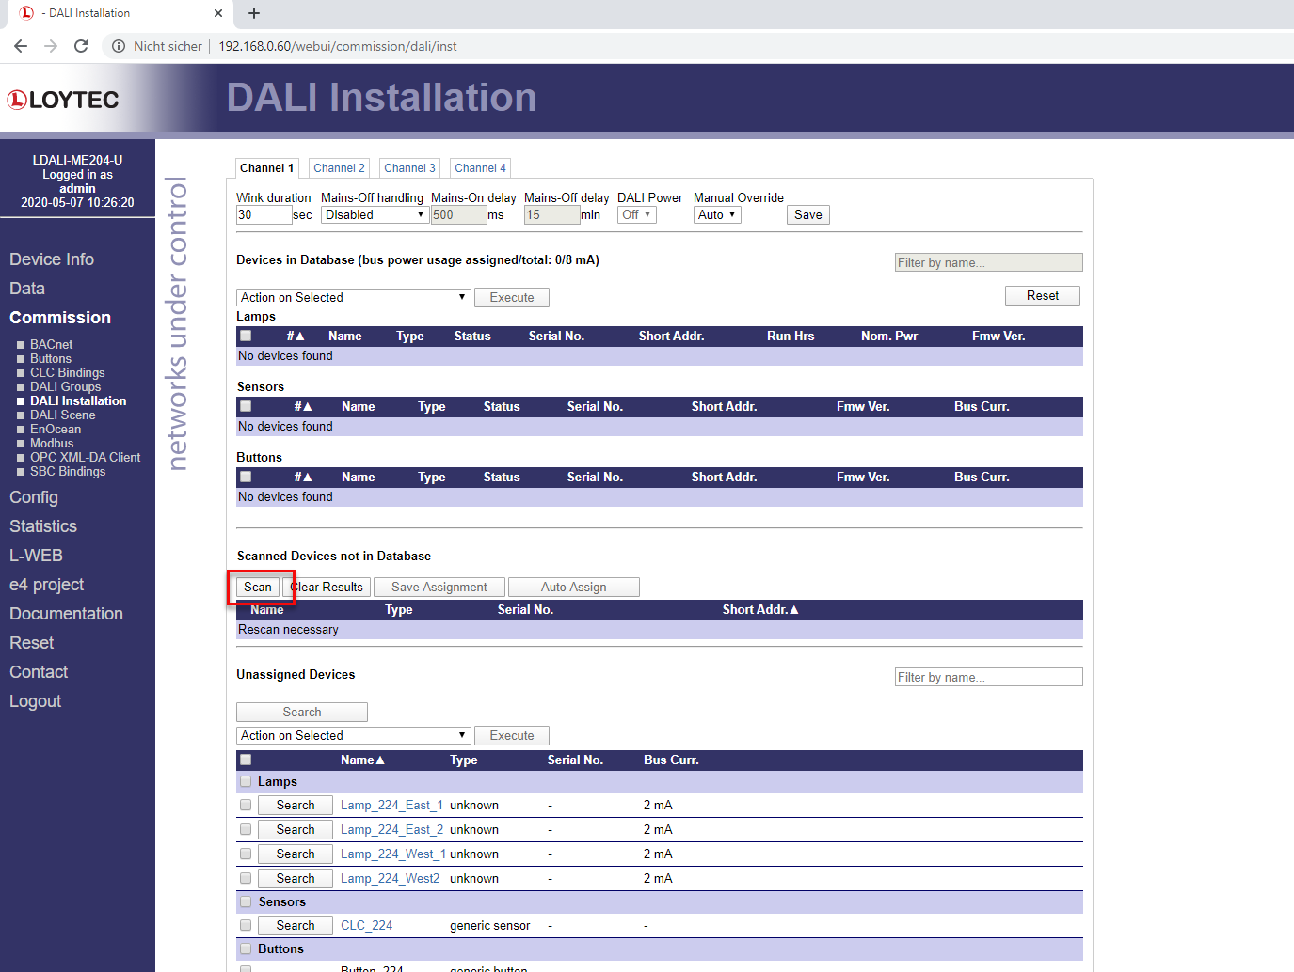

A process will be started, which searches for devices that have not been recorded in the L-DALI database. In case new devices have to be added to an existing network, the bus simply needs to be scanned to detect the new devices without changing the existing setup.

There are two possibilities to identify lamps: a wink command or a binary search. Pressing the "wink" button will let the corresponding lamp blink for a configurable time.

A binary search algorithm reduces the effort for searching lamps in a big DALI network. Go to the lamp which you want to identify and start the wizard.

50% of all lamps will be switched on, and the wizard will ask, you, if the lamp is switched on (yes/no). If the answer is “yes”, the algorithm knows that your lamp is one of the lamps it switched on. Otherwise it knows, that it must be one of the other lamps. Then it switches on 50% of the lamps of the subset and so on, until the lamp is identified. To identify one lamp out of 64, the algorithm needs 6 steps.

For identifying a sensor, the algorithm will make use of the wink function.

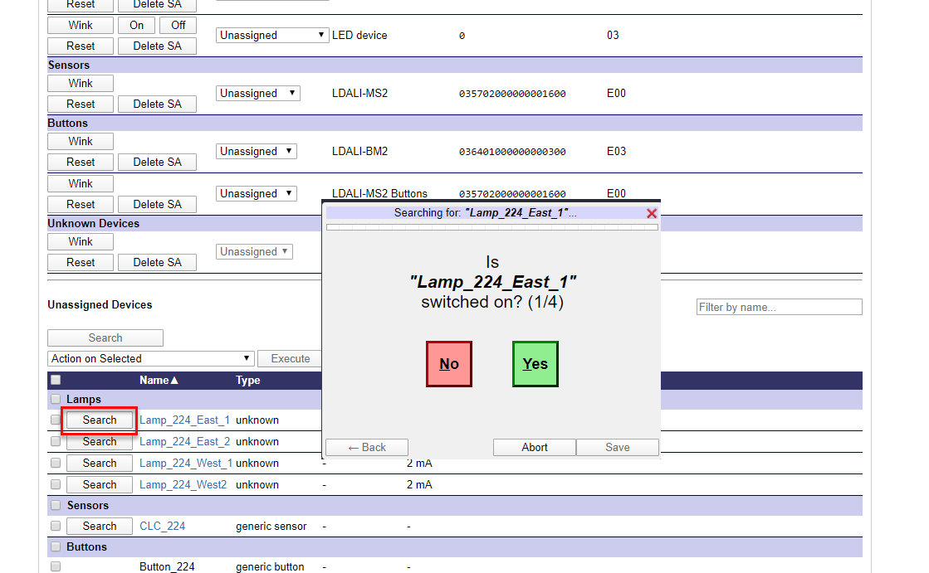

Please have a look at the following video for details:

https://youtu.be/dDzj2nhxCFw